GSWS IRCTC ID Creation Data

Introduction:

The GVWV & VSWS Department decided to integrate B2C services along with G2C services in the AP Seva portal at DA/WEDPS login. As a first step, the Department wants to integrate IRCTC services for booking railway tickets at the Secretariats. To achieve the same, it is requested all the DA/WEDPS to provide the details in the below format so as to enable IRCTC logins at all secretariats.

Details to be provided by DA/WEDPS:
- Full name as per Aadhaar
- Mobile Number (Earlier Not Used for IRCTC)
- Email Id (Earlier Not Used for IRCTC)
- PAN Number
- Aadhaar Number

Also, it is to note that the form should be filled only by the designated functionary of that particular Secretariat, and any vacant/ In-Charge/ Not-Mapped Secretariats are to be left blank.

IRCTC ID Creation- Service Flow:
- Enter DA/WEDS login https://vswsonline.ap.gov.in/#/home in AP Seva Portal
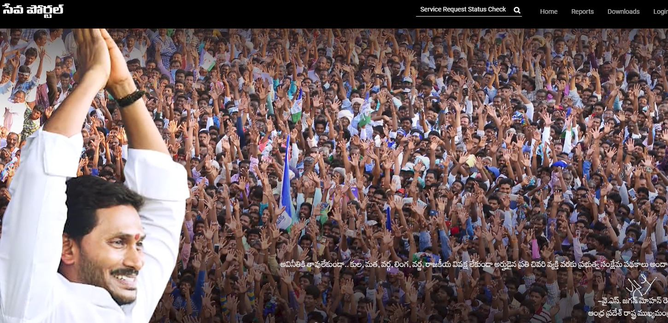

- After login that to select on Other services
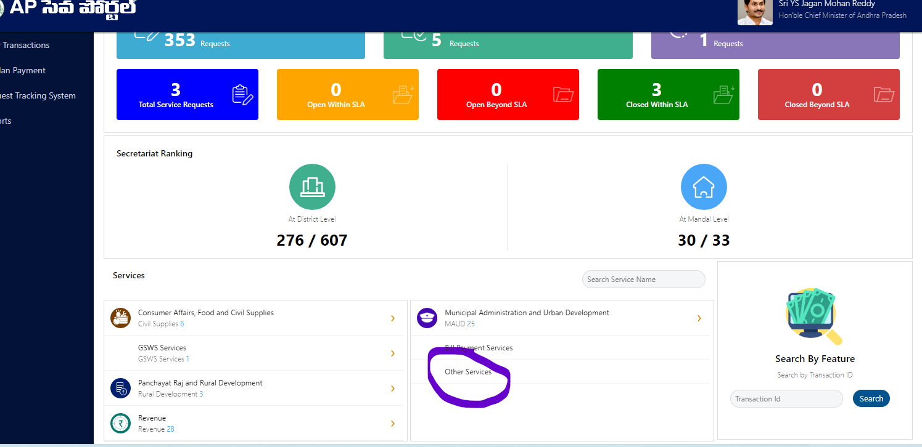

- Redircted to old portal
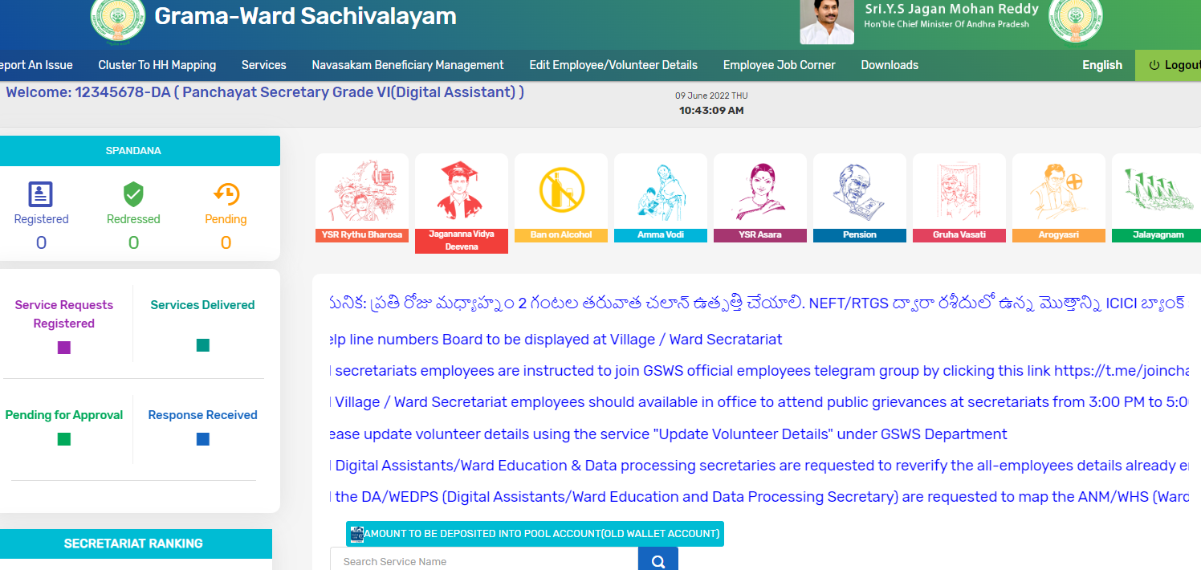

- To Select on services
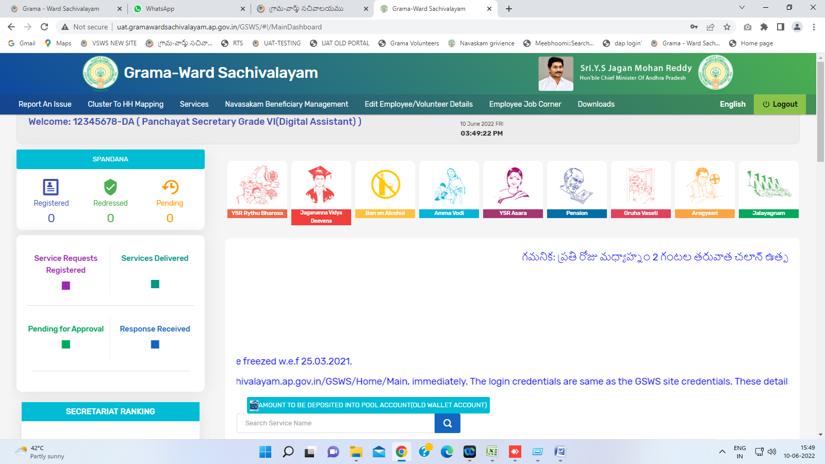

- Select on services in IRCTC ID creation data
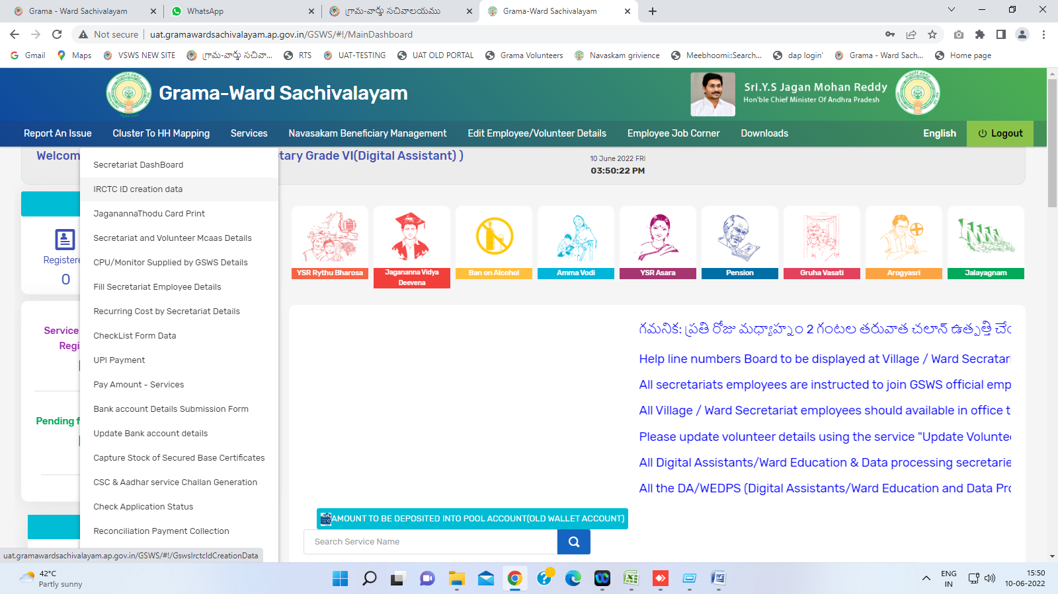
- Screen is displayed in given below
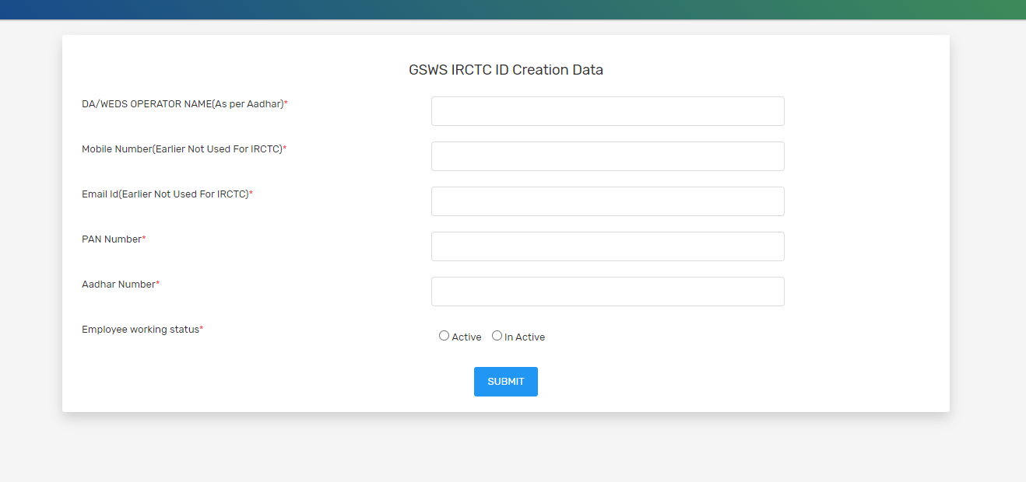

- Fill the all details and click on submit button
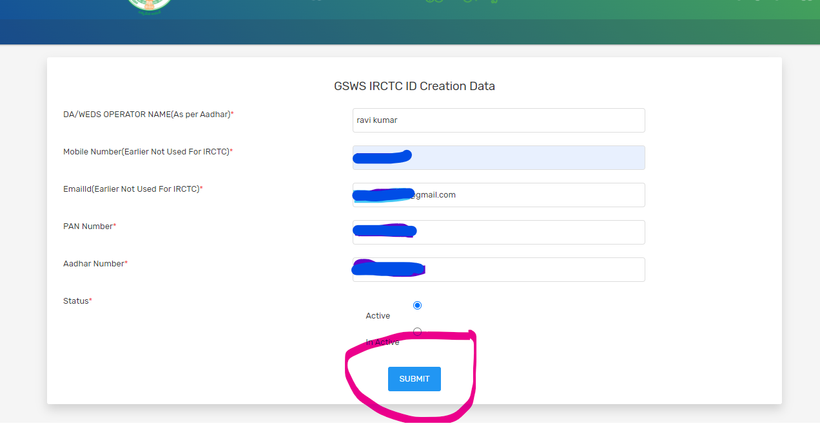

- Finally data submitted Successfully displayed
